

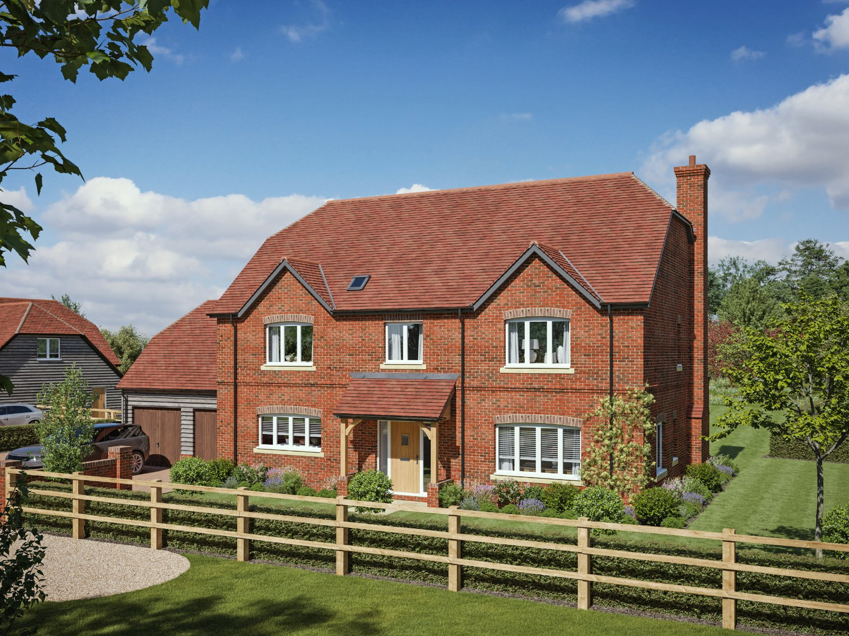

01635 35010

#

FREEHOLD GUIDE PRICE
£1,250,000
Meadow Farm House
Brook Street Great Bedwyn SN8 3NA
*Computer Generated Images are indicative and for illustration purposes only*

Tailor your dream home at Meadow Farm, Great Bedwyn. An exceptional opportunity to purchase your perfect countryside retreat.

A HOME MADE FOR YOU
Secure your own plot and work closely with one of the region’s respected developers to have the opportunity to discuss extras and specification (dependent on stage of contract).

STUNNING LOCATION
Nestled on the edge of the picturesque village of Great Bedwyn, these two four-bedroom detached homes enjoy a rare rural setting with sweeping countryside views, yet remain within easy reach of amenities, schools, and excellent rail links to London.

STAMP DUTY SAVINGS AVAILABLE
Buy now and benefit from potential stamp duty savings — an added incentive to secure one of these exclusive new homes off-plan.

PRICES FROM £1,250,000
Plots now available for early reservation. Don’t miss the chance to be involved from the ground up in a home that truly reflects your lifestyle.

Meadow Farm House individual plot measures 0.4599 acre.
SITUATION
The village is situated to the south of the historic Savernake Forest and on the northern side of the Kennet and Avon canal. It is a designated Area of Outstanding Natural Beauty with a myriad of footpaths and bridleways accessing the surrounding countryside. Local village amenities include a Post Office, church, doctors’ surgery and a public house. There is a main line railway station to Paddington (80 minutes). The provincial centres of Marlborough 7 miles, Hungerford 6 miles, Newbury 16 miles and Swindon 20 miles are all readily accessible.

- Stunning picturesque village location
- Sweeping countryside views
- Secure your own plot

- Potential Stamp Duty savings available
- Four bedroom detached home
- Now available for early reservation
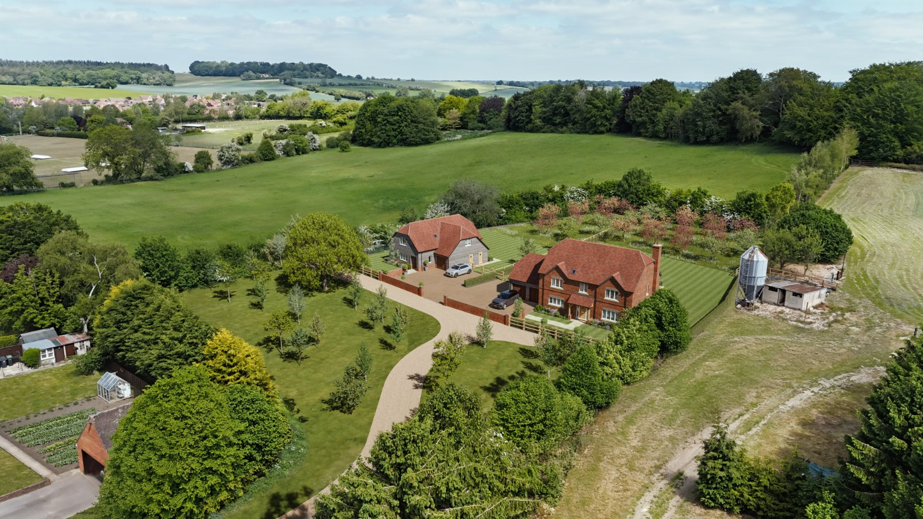

SERVICES & MATERIAL INFORMATION
The properties will operate on an air source heat pump and benefit from underfloor heating to the ground floor.

Service charge: An Annual management charge will be payable for management of the landscaped areas and access road. Please ask for further details.
EPC rating: TBC
Council tax band: Not yet available

What3words: cheerily.reserving.town

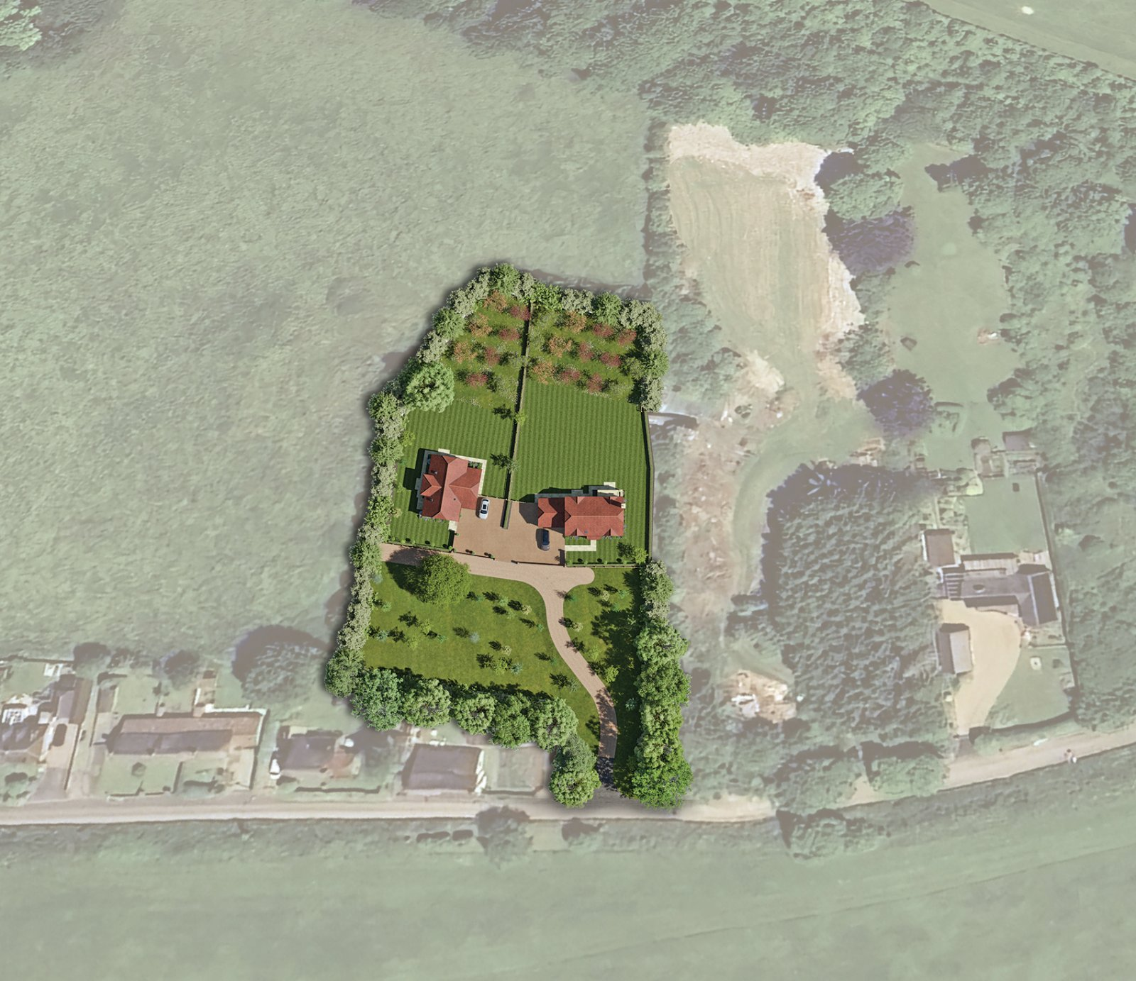
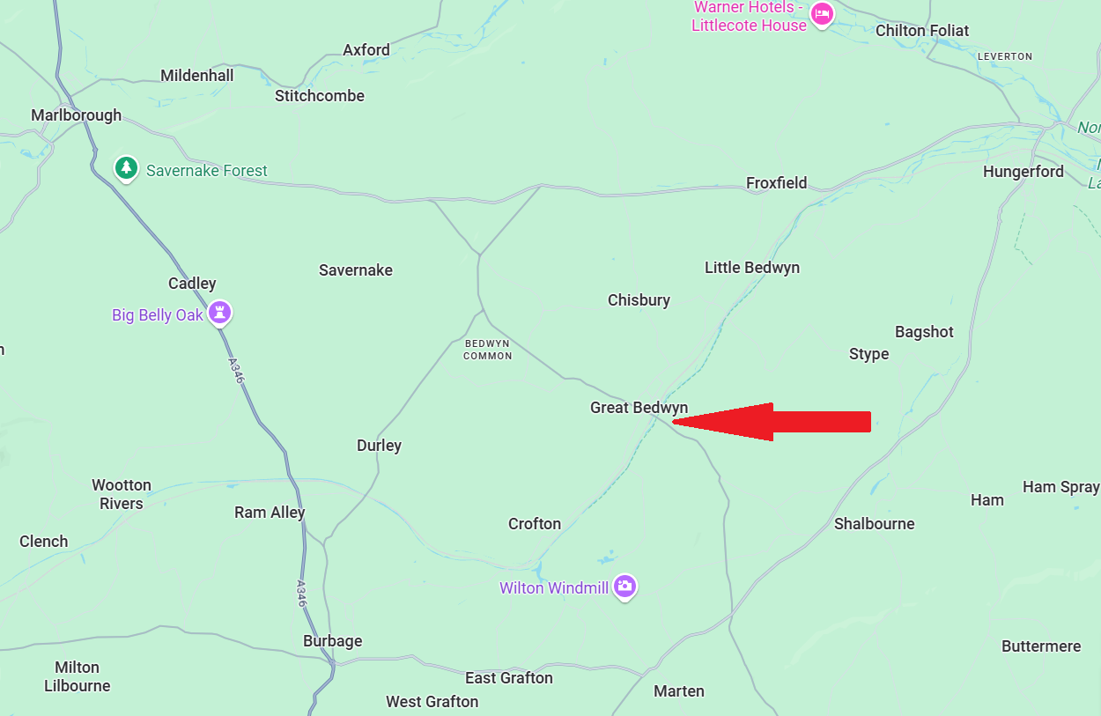

If there are any queries in relation to these property particulars, please contact this office to check the information. No responsibility can be accepted for any expenses incurred by intending purchasers in inspecting properties which have been sold, let or withdrawn. The Jones Robinson Group and the vendors of this property give notice that:
1) The sales particulars are intended to provide accurate and reliable information regarding the property for the guidance of intending purchasers. Whilst all descriptions, reference to condition, dimensions, areas, and measurements are believed to be accurate any intending purchasers should not rely on them as statements of fact and must satisfy themselves by inspection as to their correctness. 2) The particulars do not constitute part of an offer or contract with prospective purchasers. 3) All curtains, carpets, blinds equipment, light fittings and fixtures are deemed to be removable by the Vendor unless specifically negotiated with the sale of the property. 4) No person in the employment of the Jones Robinson Group has any authority to make or give representation or warranty whatsoever in relation to this property on behalf of the Jones Robinson Group, nor enter into any contract on behalf of the vendor. 5) We offer a wide range of services through third party providers including solicitors, mortgage providers, EPC suppliers and other contractors. You are under no obligation to use these services and it is Your discretion whether You choose to deal with these providers or use Your own preferred supplier. Our mortgage provider pays us a referral fee, the amount of which varies depending on the individual mortgage, however, the average fee received by us is £462 per referral (based on total referrals across all Jones Robinson offices in 2024). Our recommended mortgage provider is FirstXtra. For referrals to our recommended conveyancing firms, the average referral fee is £422.84 for Live Conveyancing or £125 for Angel Wilkins per referral (based on total referrals across all Jones Robinson offices in 2024). Contractors including EPC providers – the amount we receive varies depending on the contractor, however our average fee is £24 per referral, based on total referrals in 2024. Full details of our referral fees are listed on our website.
01635 35010
sales@jonesrobinson.co.uk
www.jonesrobinson.co.uk
Jones Robinson
118 Bartholomew Street
Newbury
RG14 5DT

